January 22, 2025

The Honorable John Thune Majority Leader

United States Senate Washington, DC 20515

Dear Majority Leader Thune:

We write regarding the pressing border security and immigration needs facing our country. As we have shown, Democrats and Republicans can work together on real bipartisan solutions. We can solve big challenges when we work together, and there is much work to do to improve border security, protect Dreamers and farmworkers, and fix our immigration system to better reflect the needs of our country and our modern economy. These issues require bipartisan cooperation and we stand ready to work with you to develop meaningful and long-lasting solutions to these important issues that have gone unaddressed for far too long under both Democratic- and Republican-controlled government.

We understand that Senate Republicans have discussed using the budget reconciliation process to advance border security budget measures without any Democratic input. While that's your right, in working together on a bipartisan basis, we can achieve the best outcome for the American people. There are also limitations to what can be done under budget reconciliation, and as we've seen time and time again, no party has all the solutions on this or any issue.

There is a lot of common ground for us to start on. We see a need for strong, commonsense, and fair immigration enforcement accompanied by the necessary resources to effectively secure our borders. That's important for our national security and to support border states. We also see a need for a firm but fair immigration system that streamlines processes and better addresses our workforce needs.

The American people are counting on us to find bipartisan solutions to our nations' priorities. We remain ready to work with you in good faith to craft legislation that can achieve bipartisan support and 60 votes in the Senate. While there will be challenges, addressing the pressing needs of our nations' borders and finding bipartisan solutions to our outdated immigration system are too important to ignore in the 119th Congress.

Thank you for your consideration.

Sincerely,

Mark Kelly

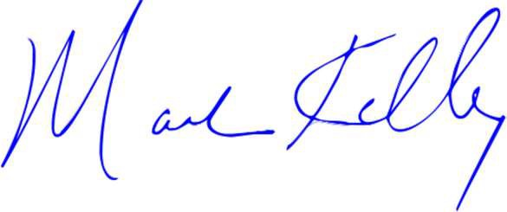

United States Senator

Gary C. Peters United States Senator

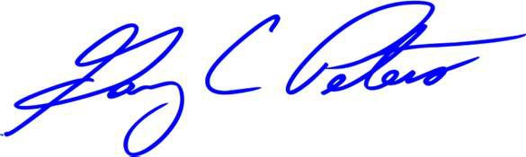

Angus S. King, Jr.

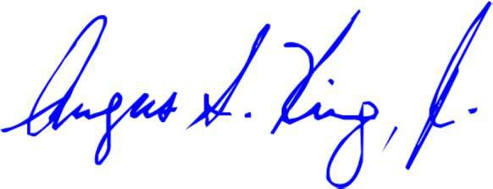

United States Senator

Jeanne Shaheen

United States Senator



Christopher A. Coons

United States Senator

Mark R. Warner

United States Senator



Margaret Wood Hassan United States Senator

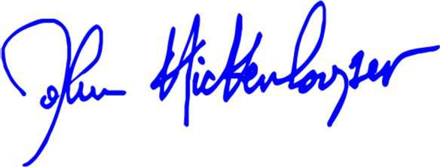

Catherine Cortez Masto United States Senator

Jacky Rosen

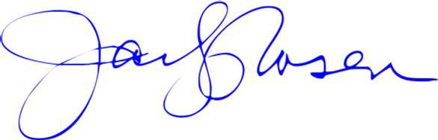

United States Senator

John Hickenlooper United States Senator



Raphael Warnock

United States Senator

Ruben Gallego

United States Senator



Elissa Slotkin

United States Senator